UDC (size of type – 11 pt, alignment left, without indentions, bold)
<– empty string – 11 pt
¹N. Surname-1, ²N. Surname-2 (size – 11 pt, bold)
¹ position and employment place, city
(11 pt, right-alignment, italic)
e-mail: adress@gmail.com
orcid: 0000-0000-0000-0000
² Professor of the Department of Design and Architecture Fundamentals
Lviv Polytechnic National University, Lviv
orcid: 0000-0000-0000-0000
<– empty string – 11 pt
<– empty string – 11 pt
TITLE OF THE ARTICLE
(TEXT SIZE - 14 PT, BOLD, CENTRE-ALIGNMENT)
<– empty string – 11 pt
© Surname-1 N., Surname-2 N. 2019 (11 pt, italics, left-alignment without indentions)
<– empty string – 11 pt
Abstract has to be presented in Ukrainian, the scope 50-100 words, word «abstract» is not needed, text size – 11 pt; bold italic type, align text relative to the page width; left indent – 1 cm, paragraph indent – 1cm.
Key words: up to 6 key words or phrases can be submitted, text size – 11 pt; bold, italic, align text relative to the page width; left indent – 1 cm, paragraph indent – 1cm.
<– empty string – 11 pt
<– empty string – 11 pt
Problem statement
(all the names of the structural elements of the article should be centre-aligned without paragraphs and indents, text size – 11 pt, bold)
The problem statement is presented in general form. It describes the relevance of the research and its relation to the scientific or practical tasks that need to be addressed and to which the article is devoted (text size – 11 pt, align text relative to the page width, paragraph indent – 1cm.)
<– empty string – 11 pt
Analysis of recent research and publications
This section provides a brief analysis of recent research and publications that address the issue of the article and which the author relies on (preferably a brief analysis of recent publications in professional journals) (text size – 11 pt, align text relative to the page width, paragraph indent – 1cm.)
<– empty string – 11 pt
Objective of the article
The section describes the purpose of the article, which should be aimed at solving the problem mentioned in the section Problem statement. It shows what results this goal will achieve and how it will influence further research in this direction. The purpose of the article must demonstrate the novelty and practical meaning of the article; it must be clear. It is forbidden to write abstract statements and general phrases. The author should identify 2-5 steps by which the goal of the study is achieved (text size – 11 pt, align text relative to the page width, paragraph indent – 1cm.)
<– empty string – 11 pt
Results and discussions
This section describes the methodology of the study, highlights the main results of the study and provides a justification. (text size – 11 pt, align text relative to the page width, paragraph indent – 1cm.)
Word wraps are not allowed. When writing surnames and initials, quantities and units, a non-breaking space is used (<Ctrl> + <Shift> + <space>). Abbreviations should end with a point (.), e.g. fig. (Number). In the text, you can use conventional abbreviations such as e.g., etc. If abbreviations used only for this article or for a narrow range of topics, their complete decoding should be indicated.
Figures (diagrams, photos) are submitted for print in black and white (GRAYSCALE) after first referencing them. For the electronic version, colour photographs are taken in RGB COLOR 24bit image mode. Picture mode is set while scanning or preparing illustrations. Illustrations should be in raster format *.jpg and *.png. Photos should also be contrasting. Printing resolution should be 300 dpi (according to the actual image size in the text of the article).
The figures are inserted into tables that are divided into two rows: the image is directly inserted at the top and the figure number caption at the bottom. The text contains the number of a figure (Fig. 1). Table contents should be centre-aligned.
<– empty string – 11 pt
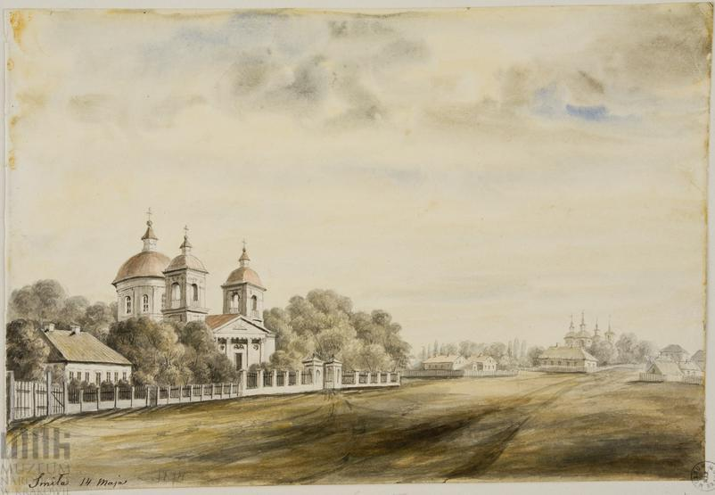
Fig.1. N. Orda. Smila, 14th of May, 1874, fragment. (text size - 14 pt, italic, centre-alignment)
<– empty string – 11 pt
Fig.3. N. Orda. Smila, 14th of May, 1874 (text size - 14 pt, italic, centre-alignment) | Fig.4. N. Orda. Smila, 14th of May, 1874. (text size - 14 pt, italic, centre-alignment)
<– empty string – 11 pt
The notation keys should be clear, distinguishable, and be deciphered in legend. Fonts at images should be legible (not less than 9 pt). Graphic scales should be added to the architectural drawings, measurements (including architectural and archaeological).
Tables should be created in Word editors without a fill. Each table must be printed with the appropriate heading and numbering after the first reference. Table widths should not exceed page margins. The font in the table must match the font of the article. Units of measurement should be given in the table header in brackets (mm). For decimal fractions, use a point (not a comma!) as a separator. Do not include vertical lines of the table (text size – 11 pt, align text relative to the page width, paragraph indent – 1cm.)
<– empty string – 11 pt
Soil stratigraphy (text size – 11 pt, right-alignment). Tab 1.
<– empty string – 11 pt
Depth (m) | Gravel (%) | Sand (%) | Clay (%)
5 | 3.4 | 81.5 | 15.2
50 | 2.8 | 58.2 | 41.3
100 | 0.0 | 32.3 | 71.1
<– empty string – 11 pt
Formulas should be placed in the centre, with the numbering at the end of the line. Formula size in the formula editor MS Equation: basic – 12; large index – 7; small index –5; large character – 18; small character – 12. Formula style is “straight”. It is forbidden to use graphical objects, frames and tables for the formula set.
<– empty string – 11 pt
Conclusions
The conclusions include a brief formulation of the research findings, summarize the findings and recommendations that come from the study, emphasize on their practical relevance, and identify the main vectors for further research in this direction. In this section, it is necessary to compare the results obtained with the goal indicated at the beginning of the work. (text size – 11 pt, align text relative to the page width, paragraph indent – 1cm.)
<– empty string – 11 pt
Bibliography
Collins German-English Dictionary, 1993. 2nd edn. Stuttgart: Klett.
Silverman, D.F. and Propp, K.K. eds., 1990. The active interview. Beverly Hills, CA: Sage.
Григоренко, П., Томак, М. та Тисячна Н. 2013. Приховування історичної правди. 2-ге вид. Київ: Українська прес-група
Домбругов, М.Р., 2012. Звіт про діяльність Асоціації УРАН в 2011 р. [online] Ukrainian Research & Academic Network. Доступно: <http://www.uran.net.ua/archives/2011apr-zbory/first.htm> [Дата звернення 12 квітня 2013].
Книжкова палата України імені Івана Федорова, 2016. Видавнича діяльність. [online] (Останнє оновлення 29 Січень 2016) Доступно: <http://www.ukrbook.net/vydav_dil.html> [Дата звернення 10 Лютий 2016].
Пилипчук, В.П., Данніков, О.В. та Ямчинська, А.С., 2009. Впровадження інноваційних продуктів та розвиток ринку FMCG. Економічний вісник НТУУ «КПІ», 6, с.294-301.
(text size – 11 pt, align text relative to the page width, paragraph indent – 1cm.)
<– empty string – 11 pt
References
Collins German-English Dictionary, 1993. 2nd edn. Stuttgart: Klett.
Silverman, D.F. and Propp, K.K. eds., 1990. The active interview. Beverly Hills, CA: Sage.
Hryhorenko, P., Tomak, M. and Tysyachna, N. 2013. Hiding the historical truth. 2nd edn. Kyyiv: Ukrayinsʹka pres-hrupa
Dombruhov, M.R., 2012. Report on the activities of the URAN Association in 2011. [online] Ukrainian Research & Academic Network. Available at: <http://www.uran.net.ua/archives/2011apr-zbory/first.htm> [Accessed 12 April 2013].
Knyzhkova palata Ukrayiny imeni Ivana Fedorova, 2016. Publishing activity. [online] (Last updated 29 January 2016) Available at: http://www.uran.net.ua/archives/2011apr-zbory/first.htm> [Date of reference 10 February 2016].
Pylypchuk, V.P., Dannikov, O.V. ta Yamchynsʹka, A.S., 2009. Introduction of innovative products and development of the FMCG market. Ekonomichnyy visnyk NTUU «KPI», 6, pp.294-301.
(text size – 11 pt, align text relative to the page width, paragraph indent – 1cm.)

A Harvard-style of British Standard of the intra-text reference system and bibliography list is to be used. Rules and examples for bibliography writing are provided in Appendix 1.
The bibliography list is to be presented in alphabetical order by author's name (not the order of references in the text) and should be written in a column (text size – 11 pt, align text relative to the page width, paragraph indent – 1cm.). Intra-text references are given in the original language as well as a bibliographic list (before which we write the title "Бібліографія"), after which the entire list is duplicated in Latin (before which we write the heading "References"), all references are transliterated, and the names of the works are translated.
<– empty string – 11 pt
<– empty string – 11 pt
¹N. Surname-1, ²N. Surname -2 (size – 11 pt, bold)
¹ Present post and place of work, city
(11 pt, right-alignment, italic)
e-mail: adress@gmail.com
orcid: 0000-0000-0000-0000
² Professor of the Department of Design and Architecture Fundamentals
Lviv Polytechnic National University, Lviv
e-mail: adress@gmail.com
orcid: 0000-0000-0000-0000
<– empty string – 11 pt
<– empty string – 11 pt
TITLE OF THE ARTICLE
(text size - 14 pt, bold, centre-alignment without paragraph indent)
<– empty string – 11 pt
© Surname-1 N., Surname -2 N. 2019 (size – 11 pt, italic, left-alignment without paragraph indent)
<– empty string – 11 pt
Abstract: in English, up to 2000 symbols (text size – 11 pt; italic, bold, align text relative to the page width; left indent – 1 cm, paragraph indent – 1cm.)
Attention! The quality of the English translation of the abstract to the article, and if necessary the article itself, is determined by the editorial board of the journal. Provided that the quality of the English translation is poor, the editorial board reserves the right to reject the article and send it to the author for revision. Machine translation is forbidden!
English abstract should contain a summary of the article, including problem statement, analysis of recent research and publications, an objective of the article, results and discussions and conclusions. Structural or content elements can be separated by paragraphs.
<– empty string – 11 pt
Keywords: up to 6 keywords or phrases can be submitted (text size – 11 pt; italic, bold, align text relative to the page width; left indent – 1 cm, paragraph indent – 1cm.)

