UDC 528.18:629.783
BOGDAN PALIANYTSIA^{1*}, ...............

¹ Department «Higher geodesy and astronomy» of National university Lviv polytechnic, 12 Bandera street, Lviv, Ukraine, 79013, e-mail bohdan.b.palianytsia@lpnu.ua, bodya1379@gmail.com

² Department of Computational Mathematics, Ivan Franko National University of Lviv, 1, Universytetska St., Lviv, Ukraine, 79000, e-mail oksana.palianytsia@lnu.edu.ua
https://doi.org/
RESEARCH OF SHORT-PERIODIC CHANGES IN THE COMPONENTS OF ZENITH THROPOSPHERE DELAY
The aim of this work - research of the magnitude of the change in the components of the zenith tropospheric delay for the territory of Ukraine according to several-day ground-based meteorological measurements, as well as the construction and study of the field of their change. Method. The accuracy of the determination of the tropospheric delay depends on the amount of meteorological data that can be used to calculate it. It is better if, at the time of the GNSS measurements, the atmospheric sensing data were obtained near the observation point, otherwise it is necessary to simulate the meteorological situation at the time of the measurements using the data available for that purpose. The fulfilled researches evaluated the meteorological situation as a whole for the territory of Ukraine. The tropospheric delay was calculated using the well-known Saastamoenen formula. The range of change of tropospheric delay for the territory of Ukraine was subsequently created. Results. The results of the research make it possible to analyze the dependence of the change in the magnitude of the components of the tropospheric delay on the change in meteorological values in the territory of the country. The graphs of changes in tropospheric delay components during three days with the discreteness of 6 hours at four points with different climatic conditions were obtained and analyzed in the work. It is established that despite the significant difference in the values ​​of the components, the amplitudes of their change are close to each other: the differences of these amplitudes are 6 mm for the dry component and 2 mm for the wet component. The dynamics of change of dry (hydrostatic) and wet (non-hydrostatic) components during two days is shown. It is noted that their dynamics is due to the change of atmospheric pressure for the dry component and the change of water vapour pressure in the troposphere for the wet component. Scientific novelty and practical significance are in the revealed stability of the amplitude of change of components at points located in different climatic and weather conditions. Also, it was confirmed that the dynamics of change in the dry component is due to changes in atmospheric pressure, and wet - due to changes in partial pressure. The performed researches can be used to create regional models of the atmosphere and further studies of the field of change of the zenith tropospheric delay, as they relate to the change of the delay in space and time. 1800 symbols)
Key words: tropospheric delay; the impact of the troposphere on satellite measurements; methods for determining tropospheric delay; determination of components of tropospheric delay; GNSS measurements. (5-8 words

Introduction
The tropospheric delay is known to be one of the most significant factors that impair the results of GNSS measurements. Research of the methods of determining and considering this factor is an urgent task in an era of rapid development and widespread use of satellite navigation systems. At the same time, the problem of increasing the accuracy of GNSS measurements becomes more urgent, which actualizes the issue of taking into account the influence of the troposphere on the results of these measurements.
Scientists from different countries, including [Askne. et al., 1987; Baby, et al., 1988; Ifadis, et. al., 2006; Mendes, 1999], as well as in Ukraine are actively engaged in research of tropospheric delay problem. In recent years, there has been an increase in publications on the subject at the Department of Higher Geodesy and Astronomy at Lviv Polytechnic National University. In some scientific works the research of methods of determination of the value of tropospheric delay of the signal spreading from the GCC to the receiver located at the observation point is presented, [Kablak, 2013; Pazyak, & Zablotskyi, 2015, 2018; Turchin, 2015; Palyanitsa, et al., 2016; Hoptar, 2017] and in others – the amount of water vapour in the troposphere of the Earth is investigated [Zablotskyi, et. al., 2017; Paziak, 2019].
Аім
The purpose of this work is to investigate the magnitude of the change in the zenith tropospheric delay and its components for the territory of Ukraine according to terrestrial meteorological measurements, as well as to construct and study the field of change of its components.
Methodology
The accuracy of the determination of the tropospheric delay depends directly on the amount of meteorological data that can be used to calculate it. It is the best if, at the time of the GNSS measurements, the aerological sensing data of the atmosphere were obtained near the observation point. But, since such an opportunity is not available, it is necessary to model in some way the meteorological situation at the time of measurements, using the data available for this purpose. In the fulfilled researches an attempt was made to assess the meteorological situation as a whole for the territory of Ukraine and to plot functions of their changes for the given territory by calculating the values of the tropospheric delay and its components.
…………………………………..
Results
In the beginning, we took the terrestrial values of meteorological magnitudes at the points of Lviv, Kyiv, Lugansk and Odesa, obtained in the autumn, for three days with an interval of 6 hours. It should be noted that each of the points is located in a different climate zone with specific features because Lviv is near the Carpathian Mountains, Kyiv - in the more continental zone, Lugansk - in the steppe zone, and Odesa - on the seashore. According to the obtained values, the graphs of changes in the components of the tropospheric delay were plotted.
(sections with names labeled by blue must be mandatory)
(in the "Methodology" and "Results" sections there can be additional subsections with the names, which are corresponding to its content)

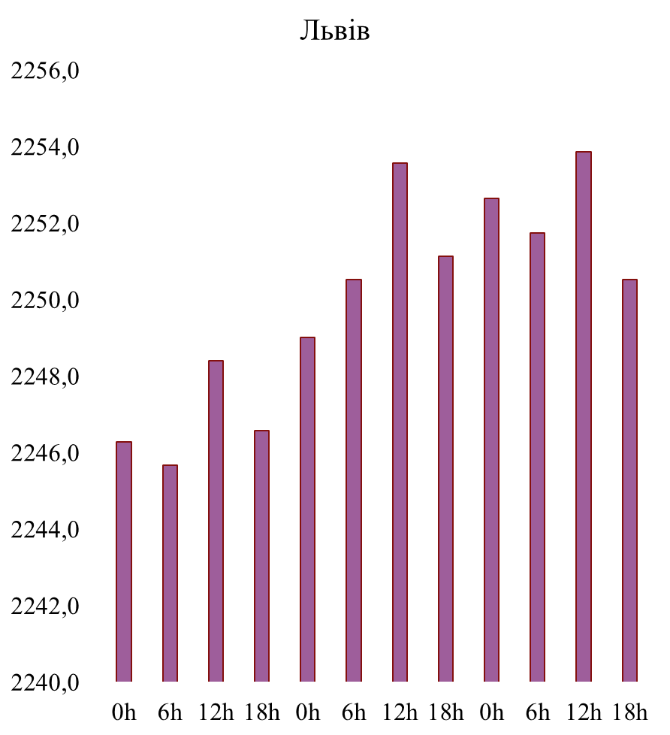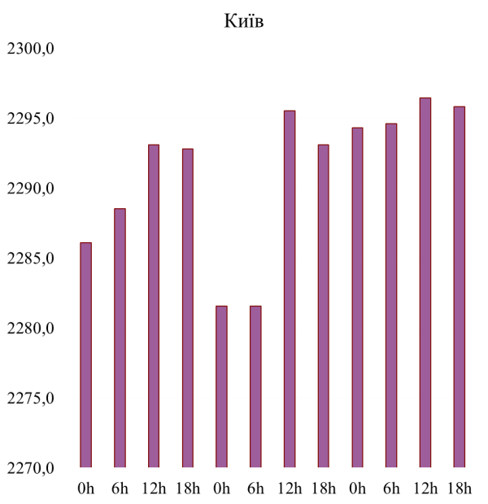
Fig. 1, 2. Change of the dry component delay for three days at the points Lviv and Kyiv

The graphs show that at the selected observation points during the specified period there is an increase in the dry component. At the points of Lviv and Odesa, the value of the delay increased evenly, and at the point of Luhansk, a sudden increase on the second day of observation was noticed. At the point of Kyiv, there was an uneven increase in the component with a rapid abatement in the first half of the second day.
The dry component varied within 15 mm, which is 0.6% compared to the average component of 2300 mm and is a slight change.
The magnitudes of component changes at selected points are shown in Tables 1 and 2. It can be seen that, despite the significant differences in the values of the corrections, the amplitudes of their changes are quite close in value, and for the wet component, they are almost equal.
Таблиця 1
Name of the point | The value of dry component, mm
Name of the point | Max. | Min. | Differences
Lviv | 2254 | 2246 | 8
Kyiv | 2295 | 2281 | 14
Lugansk | 2313 | 2300 | 13
Odesa | 2327 | 2315 | 12
Таблиця 2
Name of the point | The value of dry component, mm
Name of the point | Max. | Min. | Differences
Lviv | 140 | 96 | 44
Kyiv | 110 | 64 | 46
Lugansk | 119 | 73 | 46
Odesa | 140 | 97 | 44
………………………………………………………………………………….
Scientific novelty and practical significance
The scientific novelty of the research is in the revealed stability of the amplitude of change of components at points in different climatic and weather conditions. Also, it was confirmed that the dynamics of change in the dry component is due to changes in atmospheric pressure, and wet - due to changes in partial pressure.
The performed researches can be used to create regional models of the atmosphere and further investigate the range of change of zenith tropospheric delay, as they relate to changes of delay in space and time.
Conclusions
Considering the distribution of delay values in the territory of Ukraine for the indicated three-day period, it can be said that the dry component becomes more important in the southern and central part of the territory of Ukraine.
…………………………………………
REFERENCES
Askne, J., & Nordius, H. (1987). Estimation of tropospheric delay for microwaves from surfaces weather data. Radio Sciense, 22(3). 379-386.
Baby, H. B., Gole, P., & Lavergnal, J. (1988). A model for the tropospheric excess path length of radio waves from surface meteorological measurements. Radio Sciense. 23(6). 1023-1038.
Ifadis, I. M., Katsoungiannopoulos, S., Pikridas, C., Rossikopoulos, D., & Fotiou, A. (2006). Tropospheric Refraction Estimation Using Various Models, Radio-sonde Measurements and Permanent GPS Data. PS5.4 – GNSS Processing and Applications, XXIII FIG Congress, Munich, Germany, October 8-13, 2006. P. 15.
Kablak, N. (2013). Method of determinating the influence of results troposphere GNSS-measurements in a network of active reference stations. Modern achievements in geodetic science and industry, І(25). 62–66.
Khoptar, A. (2017). Method of determining of tropospheric parameters from compatible data of SLR and GNSS observations. Modern achievements in geodetic science and industry, ІІ(34).51– 54.
………………………………
(not less than 13 positions in the “References” (no more than 35), not less than half of them not older than 2000; not less than 5 positions non-cyrillic (in origins) of the rating journals)

.

б. б. паляниця^{1*}, Б. в. кладочний¹, О. б. паляниця²

¹ Кафедра вищої геодезії та астрономії, Національний університет «Львівська політехніка», вул. С. Бандери 12, Львів, Україна, 79013, ел. пошта bohdan.b.palianytsia@lpnu.ua, bodya1379@gmail.com

² Кафедра обчислювальної математики, Львівський національний університет ім. Івана Франка, вул. Університетська 1, Львів, Україна, 79000, ел. пошта oksana.palianytsia@lnu.edu.ua

ДОСЛІДЖЕННЯ КОРОТКОПЕРІОДИЧНИХ ЗМІН СКЛАДОВИХ ЗЕНІТНОЇ ТРОПОСФЕРНОЇ ЗАТРИМКИ
Мета цієї роботи – дослідження величини зміни складових зенітної тропосферної затримки для території України за даними кількадобових наземних метеорологічних вимірювань, а також побудова та дослідження поля їхньої зміни. Методика. Точність визначення тропосферної затримки та її складових залежить від обсягу метеорологічних даних, які можна використати для її розрахунку. Найкраще, якщо на момент проведення ГНСС-вимірів були б дані аерологічного зондування атмосфери, отримані поблизу пункту спостережень. В іншому разі доводиться моделювати метеорологічну ситуацію на момент проведення вимірів, використовуючи доступні для цього метеорологічні дані. У виконаних дослідженнях оцінювалося метеорологічну ситуацію в цілому для території України. Складові зенітної тропосферної затримки Ключові слова: тропосферна затримка; вплив тропосфери на супутникові виміри; методи визначення тропосферної затримки; визначення складових тропосферної затримки; ГНСС-виміри……………………………………………………………………………………………………………………………………………………………………………………………………………………………………………………………………………
(For authors from other countries, informational bloc in Ukrainian will not be required (will be added in the editorial board)

Received 04.04.2020

(the total volume of the article from 8 to 18 pages)

