Title of the Paper
First Authorª, Second Author^{b}, Third Author^{a,b,}
aFirst affiliation, Address, City, Postal code, Country
bSecond affiliation, Address, City, Postal code, Country
Received: ****. Revised: ****. Accepted: ****.
© **** The Authors. Published by Lviv Polytechnic National University.
Abstract
Abstract of the paper should be written as a single paragraph using the Times New Roman font with the size of 10 pt. Line spacing is 1.1. Indention of the first line is 0.7 cm, width justification. The spacing before the paragraph is 4 pt. The size of the abstract should be from 100 to 150 words. Do not use references in the abstract. The main results and content of the paper should be described in the abstract concisely. The abstract should be informative.
Keywords: four to eight keywords; separated by semicolons.
- Main text
This template should be used for preparing the paper. Please do not make any changes to the formatting of this template document. The papers should be prepared in single column format suitable for direct printing onto paper with trim size of 210 x 297 mm. The main text of the paper should be typed using the Times New Roman font with the font size of 10 pt. Line spacing is 1.1. Indention of the first line is 0.7 cm, width justification. The spacing before each paragraph is 4 pt.
The file of the paper must be in MS Word (docx file). Use the “spellchecker” function of MS Word to avoid unnecessary errors. Please make sure that you use as much as possible normal fonts in your documents. Special fonts, such as fonts used in the Far East (Japanese, Chinese, Korean, etc.) may cause problems during processing. The size of the paper should be from 4 to 16 pages. It is recommended that the number of pages in the paper be even (i.e. 4, 6, 8 … 16 pages). The structure of the paper should consist of the following parts:
- definition of the problem to be solved;
- analysis of the recent publications and research works on the problem;
- formulation of the goal of the paper;
- presentation and discussion of the research results;
- conclusions.
Follow this order when typing the manuscript: Title, Authors, Affiliations, Abstract, Keywords, Main text (including figures and tables), Acknowledgements (optional), References, Appendix (optional). In the Authors line and in the header of the second page give the first name and the surname of each author. Please do not make any changes in the copyright line. The following information should be given at the end of the paper in Ukrainian: Title, Authors, Affiliations, Abstract, Keywords. For non-Ukrainian authors this information will be translated.
- Headings
Section headings should be left justified with an indention of 0.7 cm, bold, with the first letter capitalized and numbered consecutively. Sub-section headings should be in capital and lower-case bold letters, numbered 1.1, 1.2, etc, and left justified with an indention of 0.7 cm. All headings should have a minimum of three text lines after them before a page or column break. Make sure that the text area is not blank except for the last page. The spacing before the heading paragraph is 12 pt.
2.1. General guidelines for preparation of the text
Before you begin to format your paper, first write and save the content as a separate text file. Keep your text and graphic files separate even after the text has been formatted and styled.
Avoid hyphenation at the end of a line. Symbols denoting vectors and matrices should be indicated in bold type (A, b). Scalar variable names should normally be expressed using italics (C, d). Weights and measures should be expressed in SI units. Use a zero before decimal points: “0.25”, not “.25”. All non-standard abbreviations or symbols must be defined when first mentioned, or a glossary provided.
Footnotes should be avoided if possible. Necessary footnotes should be denoted in the text by consecutive superscript numbers¹. The footnotes should be typed single spaced, and in smaller type size (8 pt), at the foot of the page in which they are mentioned, and separated from the main text by a line extending at the foot of the column. When using the footnotes a section break should be inserted at the beginning of the page where the first footnote was used (except the first page of the paper). It should be done in order to change the format of the footnote superscript from symbols (*, † ,‡ , §) to numbers (1, 2, 3, 4).
Numbered lists in the main text of the paper may be included and should look like this:
- first point;
- second point;
- third point.
Please do not change the margins of the template as this can result in the footnote falling outside printing range.
- Tables, formulae and figures
All tables should be numbered with Arabic numerals. Every table should have a caption. Headings should be placed above tables, left justified to the limits of the table, font size 9 pt. The spacing before the table heading is 12 pt, and after the heading it is 4 pt. The spacing before the paragraph after the table is 12 pt. Tables must be embedded into the text and not supplied separately. The font size of the text in the table is 8 pt.
Table 1. Margins of the page.
Name of parameter | Value
Inside margin, mm | 18
Outside margin, mm | 25
Top margin, mm | 20
Bottom margin, mm | 27
Formulae and equations should be typed in one of the following editors: MathType, Microsoft Equation or Office Math Markup Language (OMML). The equations and formulae should be numbered consecutively with Arabic numerals in parentheses on the right hand side of the page (if referred to explicitly in the text). The symbol sizes in the formulae are as follows: full 10 pt, subscript/superscript 6 pt, sub-subscript/superscript 5 pt, symbol 16 pt, sub-symbol 10 pt. The paragraph spacing before and after the formula is 12 pt. Do not use MathType, Microsoft Equation or OMML for typing the variables and coefficients when referring to them in the text of the paper. Use the subscript and superscript tools and the table of symbols. Be sure that the symbols in the equation have been defined before or immediately following the equation.
$W\left(s\right)=K_{P}\left(1+\frac{1}{T_{I}s}+\frac{T_{D}s}{T_{D}s+1}\right)$, (1)
where K_{P} is the proportional gain of the PID control law; T_{I} is the reset time; T_{D} is the differentiation time; s is the Laplace transform variable.
All figures should be numbered with Arabic numerals. Every figure should have a caption. All photographs, schemas, graphs and diagrams are to be referred to as figures. Line drawings should be good quality scans or true electronic output. Low-quality scans are not acceptable! Figures must be embedded into the text and not supplied separately. Preferred formats of figures are PNG, JPEG, GIF etc. Please ensure that all the figures are of 300 DPI resolutions. The PDF versions of the papers will be published in colors. The hard copy of the journal with the papers will be printed in gray scale. Lettering and symbols should be clearly defined either in the caption or in a legend provided as part of the figure. Figures should be placed as close as possible to the first reference to them in the paper. For example, see Fig.1.
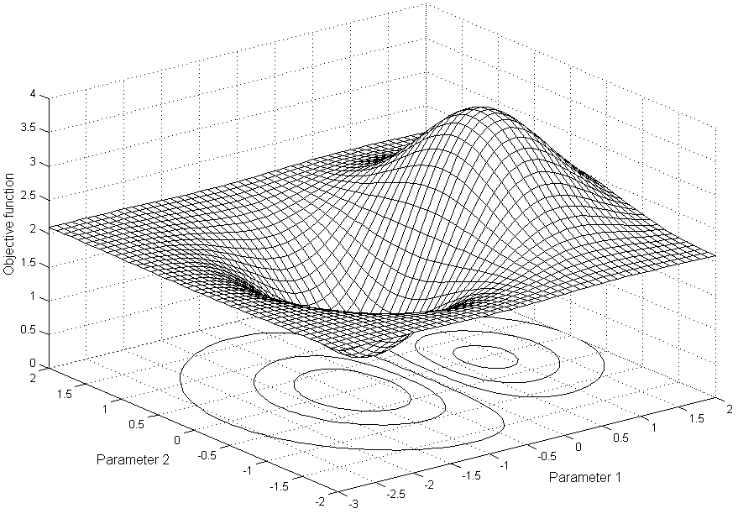
Fig.1. Objective function versus parameter 1 and parameter 2.
The figures created by means of MS Word tools should be grouped. The figure number and caption should be typed below the illustration in 9 pt and centered. The paragraph spacing before the figure is 12 pt. For the figure caption, the paragraph spacing is 4 pt before the caption and 12 pt after the caption.
- Conclusion
Conclusion should state concisely the most important propositions of the paper as well as the author’s views of the practical implications of the results. Give the most important conclusion from your paper. Do not use equations and figures in conclusions.
References
References must be listed at the end of the paper. Do not begin them on a new page unless this is absolutely necessary. Authors should ensure that every reference in the text appears in the list of references and vice versa. Indicate references by [1] or [2], [3] in the text. Do not use “Ref. [5]” or “reference [5]” except at the beginning of a sentence. There should be at least 8 references in the list. Do not include only your publications! The percentage of self-citations should be not more than 20%. Include at least one reference from indexed journals or conferences. The font size for the reference list is 8 pt. Names of non-English-language references should be translated in English. Please specify the original language in parentheses for non-English-language references.
Unless there are six authors or more give all authors’ names; do not use “et al.”. Papers that have not been published, even if they have been submitted for publication, should be cited as “unpublished”. Papers that have been accepted for publication should be cited as “in press”. Capitalize each word in a paper title, except for function words and element symbols. Examples for different references:
- Pistun, Y. , Lesovoy, L. , Matiko, F., Fedoryshyn, R. (2014) Computer Aided Design of Differential Pressure Flow Meters. World Journal of Engineering and Technology, 2, 68-77. doi: 10.4236/wjet.2014.22009.
- Malik, A.S., Boyko, O., Atkar, N. and Young, W.F. (2001) A Comparative Study of MR Imaging Profile of Titanium Pedicle Screws. Acta Radiologica, 42, 291-293. http://dx.doi.org/10.1080/028418501127346846
- Hu, T. and Desai, J.P. (2004) Soft-Tissue Material Properties under Large Deformation: Strain Rate Effect. Proceedings of the 26th Annual International Conference of the IEEE EMBS, San Francisco, 1-5 September 2004, 2758-2761.
- Ortega, R., Loria, A. and Kelly, R. (1995) A Semiglobally Stable Output Feedback PI2D Regulator for Robot Manipulators. IEEE Transactions on Automatic Control, 40, 1432-1436.http://dx.doi.org/10.1109/9.402235
- Wit, E. and McClure, J. (2004) Statistics for Microarrays: Design, Analysis, and Inference. 5th Edition, John Wiley & Sons Ltd., Chichester.
- Prasad, A.S. (1982) Clinical and Biochemical Spectrum of Zinc Deficiency in Human Subjects. In: Prasad, A.S., Ed., Clinical, Biochemical and Nutritional Aspects of Trace Elements, Alan R. Liss, Inc., New York, 5-15.
- Wright and Wright, W. (1906) Flying-Machine. US Patent No. 821393.
- R. Fedoryshyn, Y. Hren, F. Matiko. (2009) Modeling of dynamic characteristics of impulse lines of the differential pressure flow meters, Bulletin of Lviv Polytechnic National University: Heat Power Engineering. Environmental Engineering. Automation, No. 659, pp. 73-78. (in Ukrainian)
Назва статті
Перший Співавторª, Другий Співавтор^{b}, Третій Співавтор^{a,b}
aПерша організація, Адреса, Місто, Поштовий індекс, Країна
bДруга організація, Адреса, Місто, Поштовий індекс, Країна
Анотація
Анотація повинна містити від 100 до 150 слів, гарнітура Times New Roman, шрифт – кегль 10, відступ першого рядка – 0,7 см, міжрядковий інтервал – 1,1, вирівнювання по ширині. Інтервал перед абзацом – 4 пт. В анотації не застосовувати посилання на літературні джерела.
Ключові слова: від 4 до 8 слів; відділяти крапкою з комою.

Corresponding author. Email address: name@mail.com

