MOCANU L., GONTA M., PORUBIN V. (REPUBLIC OF MOLDOVA, CHISINAU)
THE CATALYTIC OXIDATION OF SODIUM LIGNOSULFONATE AND DIRECT RED DYE IN THE PRESENCE OF HYDROGEN PEROXIDE
Moldova State University
60, A. Mateevici str., Chisinau, Republic of Moldova; e-mail@gmail.com

Abstract. Based on the theory of differential equations in partial derivatives (unsteady Navier-Stokes equations for compressed gas) created a mathematical model of the generation and application of multiphase dispersed structures to ensure an acceptable level of technogenic and ecological safety for broad spectrum of certain natural and anthropogenic danger factors. The numerical modeling of these processes is carried out. The research is part of the creation and implementation of an appropriate environmental safety management system.
For filtered feed of a filter were used different samples of zeolite clinoptiolite from Sokyrnytske field with the help of a laboratory unit, which consists of containers for sewage, a pump, electric devices, а thin-layer settler and filtration columns. Results of the study in dependence on different parameters of electrotreatment, angle of gradient of inclined planes in a settler and the size of grains in zeolite fractions (mm.), which are placed in different filtrating columns, are shown in the table.
Table 1
Indices of filtrates purification with the help of electrical, chemical and sorption technique
№ | Before purification |  |  | After purification |  |  | Degree of purification α, %
1/І | 33,2 | 4,01 | 905,0 | 3,5 | 1,0 | 218,4 | 89,5 | 75,0 | 75,8
2/І | 39,8 | 4,2 | 938,0 | 3,8 | 1,05 | 224,5 | 90,4 | 75,0 | 76,0

Conclusion: Study of a filtrate purification show that conducting the purification of a filtrate in accordance with electrical, chemical and sorption technique increases the degree of its purifica-tion from ammonium nitrogen up to 89,9 – 97,8%, nitrites 89,9 – 97,8%
Sample for the formula:
$J=\frac{1}{2⋅n}⋅\sum_{i=1}^{n}{\frac{C_{i}^{\text{год}}⋅V_{i}}{{\text{ПДС}}_{i}}}+\frac{1}{\text{24}}⋅\sum_{j=1}^{n}{\frac{T_{j}}{T_{\text{фj}}+3}}$, (1)
A comparative analysis of CL emissions from stationary sources and the corresponding values of the BCH indicator for the RZP regions show that the maximum emissions for the entire period are observed in Odesa oblast.
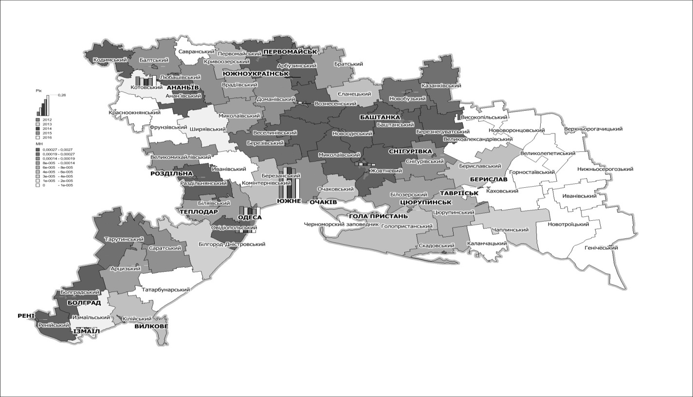
Fig. 1. Distribution of the module of technogenic load on the air basin
of the North-Western Black Sea region from stationary sources (on the example of 2013).

The second place is occupied by the Nikolaev area. The maximum values of the BCH, respectively, are observed in Odessa and Nikolaev regions (Fig. 1). The maximum volumes of CL emissions from mobile sources and the value of the BCH are observed in the Odessa region (Fig. 2).

