John Smith, Dr. of Tech. Sc., Prof.

Klara Doe, PhD., Assoc. Prof.

john.smith@lpnu.ua

klara.doe@lpnu.ua

Lviv Polytechnic National University

**TEMPLATE OF ABSTRACT FOR ATRIC-2025**

Abstracts in Ukrainian or English are accepted.

Abstracts should be 2-4 full pages of A5 text and typed in Microsoft Word (font - Times New Roman, size - 11, style - normal, line spacing - 1.2).

The size of the margins: left - 1.5 cm, right - 1.5 cm, top - 1.5 cm, bottom - 1.5 cm.

The name of the file with the abstracts should contain information about the section number and correspond to the name of the first author, for example 2_Koval.dосx

In the upper right corner (normal font, without slant and underlining):

First name and Surname of the authors;

Academic degree and academic title (abbreviated);

E-mail address;

Name of the organization (abbreviated).

The title of the report should be in capital letters, bold, without slope and underlining, in the center of the page, without hyphens, separated from the text by one free line at the top and bottom.

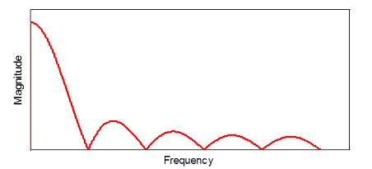

Image 1. Images or diagrams should be centered

Table 1. Table template

|  |  |
| --- | --- |
| **Title of column 1** | **Title of column 2** |
| contents | contents |
| contents | contents |

[1] V. F. Fusco, R. Cahill and Rong-Lin Li, "Quadrifilar loop antenna" in IEEE Transactions on Antennas and Propagation, vol. 51, no. 1, pp. 115-120, Jan. 2003, doi: 10.1109/TAP.2003.809046.