**GRAPHIC TOOLS AND VISUALIZATION IN URBAN STUDIES**

**Section name –** Architecture and Urban Planning / Design / Fine Arts and Restoration

**VISUAL NARRATIVES OF URBAN SPACE:**

**MAPPING, MODELING, AND INTERPRETING THE CITY**

**First Name LAST NAME**

example@gmail.com

Full Name of the Department

Full Official Name of the Educational Institution

Country

The article explores visual methods of urban space analysis, focusing on mapping, modelling, and interpretation as key tools of urban research. Special attention is given to graphic narratives that reveal spatial patterns, cultural codes, and transformation processes within the structure of the contemporary city (Figure 1).

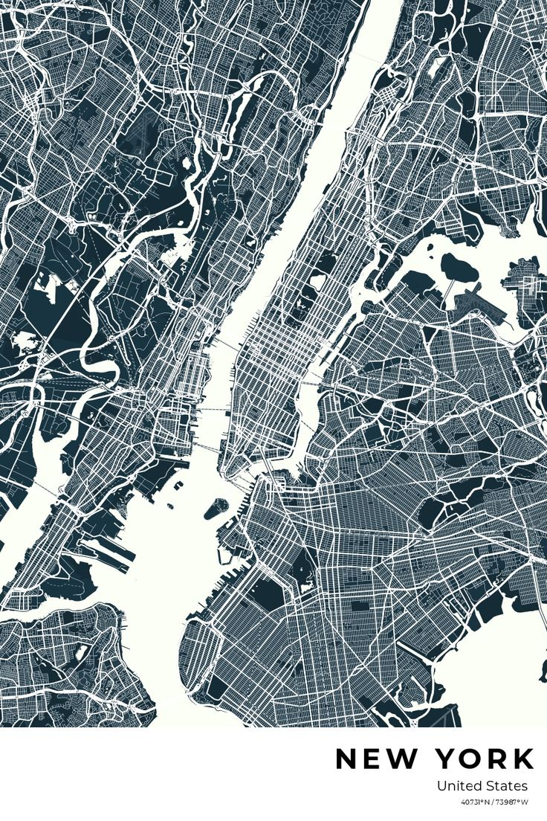

Figure 1. Title of the figure

**References**

In APA style

For books: Author(s). (Year). Title of the book. Publisher.

For journal articles: Author(s). (Year). Title of the article. Title of the Journal, Volume(Issue), page range. https://doi.org/xxxxx or URL (if available).

For online sources: Author(s) (if available). (Year) (if available). Title of the page or document. Name of the Website. URL