ADVANCES IN CYBER-PHYSICAL SYSTEMS
Vol. 10, No. 1, 2025
PREPARATION OF PAPERS FOR JOURNAL “ADVANCES IN CYBER-PHYSICAL SYSTEMS”
First Author¹, Second Author¹, Third Author²
¹ Lviv Polytechnic National University, 12, S. Bandery str., Lviv, 79013, Ukraine,
² Lublin University of Technology, 38d, Nadbystrzycka, 20-618 Lublin, Poland
Authors’ e-mails: author.first@lpnu.ua, author.v.second@lpnu.ua, p.author@pollub.pl
https://doi.org/10.23939/acps2025.02.140
Submitted on 10.03.2025
© Author F., Author S., Author Th., 2025

Abstract: Sample text inserted for illustration. Replace with abstract text. Your abstract should give readers a brief summary of your article. It should concisely describe the contents of your article, and include key terms. It should be informative, accessible and not only indicate the general scope of the article but also state the main results obtained and conclusions drawn. The abstract should be complete in itself; it should not contain undefined abbreviations and no table numbers, figure numbers, references or equations should be referred to. It should be suitable for direct inclusion in abstracting services and should not normally be more than 300 words.
Index terms: term, term, term.
- INTRODUCTION
The total length of the article should not exceed 6 pages.
Introduction should be given in this section. Font Size 10, Times New Roman, single spaced. All the subheadings in this section should be in font size 10, Times New Roman, single spaced. The first letter of each word in subheading should be capital.
- LITERATURE REVIEW AND PROBLEM STATEMENT
Literature Review should be given in this section. All the subheadings in this section should be in font size 10, capital letter, Times New Roman, single spaced.
- SCOPE OF WORK AND OBJECTIVES
- ABBREVIATIONS AND ACRONYMS
Define abbreviations and acronyms the first time they are used in the text, even after they have already been defined in the abstract. Abbreviations such as IEEE, SI, ac, and dc do not have to be defined. Abbreviations that incorporate periods should not have spaces: write “C.N.R.S.,” not “C. N. R. S.” Do not use abbreviations in the title unless they are unavoidable.
Manuscripts should be divided into ordered and numbered sections. These sections should contain sufficient details to allow others to replicate and build on published results. New methods and protocols should be described in detail while well-established methods can be briefly described and appropriately cited.
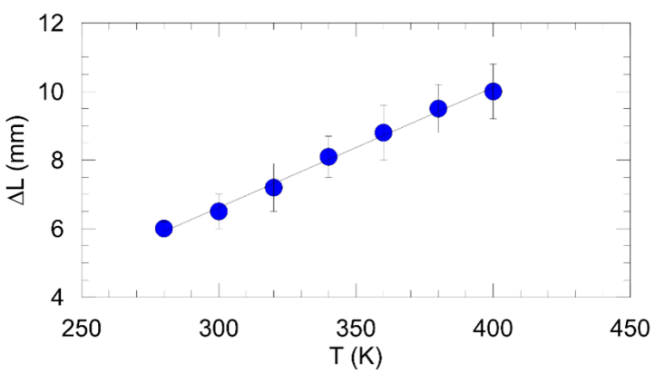
Fig. 1. This is a figure. Schemes follow the same formatting
All headings (except Introduction and Conclusion) can be divided into subsections.
- OTHER RECOMMENDATIONS
A parenthetical statement at the end of a sentence is punctuated outside of the closing parenthesis (like this). (A parenthetical sentence is punctuated within the parentheses.) In American English, periods and commas are within quotation marks, like “this period.” Other punctuation is “outside”! Avoid contractions; for example, write “do not” instead of “don’t.” The serial comma is preferred: “A, B, and C” instead of “A, B and C.”
If you want to submit your file with one column electronically, please do the following:
• First, click on the View menu and choose Print Layout.
• Second, place your cursor in the first paragraph. Go to the Format menu, choose Columns, choose one column Layout, and choose “apply to whole document” from the dropdown menu.
• Third, click and drag the right margin bar to just over 4 inches in width.
The graphics will stay in the “second” column, but you can drag them to the first column. Make the graphic wider to push out any text that may try to fill in next to the graphic.

If you wish, you may write in the first person singular or plural and use the active voice (“I observed that ...” or “We observed that ...” instead of “It was observed that ...”). Remember to check spelling. If your native language is not English, please get a native English-speaking colleague to carefully proofread your paper. [1].

By combining transactions into linked blocks and requiring majority approval for changes, blockchain provides a secure and transparent method of recording data. In the context of IoT data storage, blockchain offers several advantages:
- Technical papers submitted for publication must advance the state of knowledge and must cite relevant prior work.
- The length of a submitted paper should be commensurate with the importance, or appropriate to the complexity, of the work. For example, an obvious extension of previously published work might not be appropriate for publication or might be adequately treated in just a few pages.
- Authors must convince both peer reviewers and the editors of the scientific and technical merit of a paper; the standards of proof are higher when extraordinary or unexpected results are reported.
- Because replication is required for scientific progress, papers submitted for publication must provide sufficient information to allow readers to perform similar experiments or calculations and use the reported results. Although not everything need be disclosed, a paper must contain new, useable, and fully described information.
Storing and managing IoT telemetric data in logistics requires selecting a specific blockchain platform that supports the necessary features and scalability [2].
- MATH
If you are using Word, use either the Microsoft Equation Editor or the MathType add-on (http://www.mathtype.com) for equations in your paper (Insert | Object | Create New | Microsoft Equation or MathType Equation). “Float over text” should not be selected.
Number equations consecutively with equation numbers in parentheses flush with the right margin, as in (1). First use the equation editor to create the equation. Then select the “Equation” markup style. Press the tab key and write the equation number in parentheses. To make your equations more compact, you may use the solidus ( / ), the exp function, or appropriate exponents. Use parentheses to avoid ambiguities in denominators. Punctuate equations when they are part of a sentence, as in
, (1)
Be sure that the symbols in your equation have been defined before the equation appears or immediately following. Italicize symbols (T might refer to temperature, but T is the unit tesla). Refer to “(1),” not “Eq. (1)” or “equation (1),” except at the beginning of a sentence: “Equation (1) is ... .”
Table 1
Pyramid-like MBAs hardware complexity results
MBA  bit-length | Classical HA gate number (А₁) | Improved HA gate number (А₂)
8 | 180 | 108
16 | 680 | 408
32 | 2640 | 1584
64 | 10400 | 6240
128 | 41280 | 24768
256 | 164480 | 98688
512 | 656640 | 393984

- CONCLUSION
A conclusion section is not required. Although a conclusion may review the main points of the paper, do not replicate the abstract as the conclusion. A conclusion might elaborate on the importance of the work or suggest applications and extensions.

References
- Vazhenina, L. V., Magaril, E., &Mayburov, I. (2023). Digital management of resource efficiency of fuel and energy companies in a circular economy. Energies, 16(8), 3498. DOI: https://doi.org/10.3390/en16083498.
- Poroshenko, P. (2023). The law of Ukraine on housing and communal services [Electronic resource]. Verkhovna Rada. Available: https://zakon.rada.gov.ua/laws/show/
2189-19#Text.
- Central Drug Research Institute (2022). Energy management and monitoring systems, 171–185. DOI: https://doi.org/10.1201/9781003157137-7.
- Mary, J. S. N. (2022). Design of digital meters for industries using data acquisition system. IOP Conference Series: Materials Science and Engineering, 1258(1), 012047. DOI: https://doi.org/10.1088/1757-899x/1258/1/012047.
- Li, Y., Xiao, T. C., Wang, J., & Ding, Z. (2022). Comprehensive energy metering collection and detection management by computer network technology. IEEE International Conference on Digitalization & Smart City Applications (ICDSCA), 375–379. DOI: https://doi.org/10.1109/ICDSCA56264.2022.9987908.
- Gannavaram, T. K., & Reddy, G. R. (2021). IoT based electricity energy meter. Social Science Research Network. DOI: https://doi.org/10.2139/SSRN.3875420.
- Su, M., Jiao, X., Li, J., Wu, S., & Wu, T. (2021). Accuracy and reliability analysis of pipe irrigation metering device for sandy water source. Water, 13(7), 947. DOI: https://doi.org/10.3390/w13070947.
- Goeller, T., Wenninger, M., & Schmidt, J. (2018). Towards cost-effective utility business models: Selecting a communication architecture for the rollout of new smart energy services, 231–237. DOI: https://doi.org/10.5220/0006759202310237.
- Lee, J., Choi, W., & Kim, J. (2021). A cost-effective CNN-LSTM-based solution for predicting faulty remote water meter reading devices in AMI systems. Sensors, 21(18), 6229. DOI: https://doi.org/10.3390/S21186229.
- Herrmann, M. R., Costanza, E., & Brumby, D. P. (2021). Exploring domestic energy consumption feedback through interactive annotation. Energy Efficiency, 90. DOI: https://doi.org/10.1007/s12053-021-09999-0.

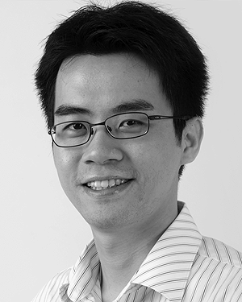
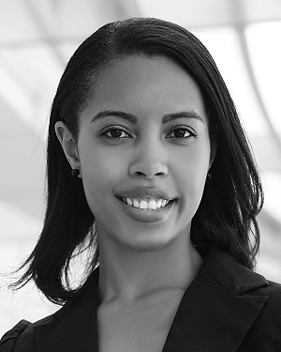
First Author and the other authors may include biographies at the end of regular papers. Biographies are often not included in conference-related papers. This author became a Member (M) of IEEE in 1976, a Senior Member (SM) in 1981, and a Fellow (F) in 1987. The first paragraph may contain a place and/or date of birth (list place, then date). Next, the author’s educational background is listed. The degrees should be listed with type of degree in what field, which institution, city, state, and country, and year the degree was earned. The author’s major field of study should be lower-cased.

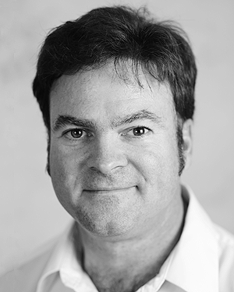
Second Author was born in Greenwich Village, New York City, in 1977. He received the B.S. and M.S. degrees in aerospace engineering from the University of Virginia, Charlottesville, in 2001 and the Ph.D. degree in mechanical engineering from Drexel University, Philadelphia, PA, in 2008.

From 2001 to 2004, he was a Research Assistant with the Princeton Plasma Physics Laboratory. Since 2009, he has been an Assistant Professor with the Mechanical Engineering Department, Texas A&M University, College Station. His research interests include high-pressure and high-density nonthermal plasma discharge processes and applications.

Third Author, Jr. (M’87) received the B.S. degree in mechanical engineering from National Chung Cheng University, Chiayi, Taiwan, in 2004 and the M.S. degree in mechanical engineering from National Tsing Hua University, Hsinchu, Taiwan, in 2006. He is currently pursuing the Ph.D. degree in mechanical engineering at Texas A&M University, College Station.

From 2008 to 2009, he was a Research Assistant with the Institute of Physics, Academia Sinica, Tapei, Taiwan. His research interest includes the development of surface processing and biological/medical treatment techniques using nonthermal atmospheric pressure plasmas.

